DATA VISUALIZATION ON SUPERMARKET SALE ANALYSIS

NAME: TAMIZHARASAN.K

NM ID: au611220104161

UPLOADING THE DATA:

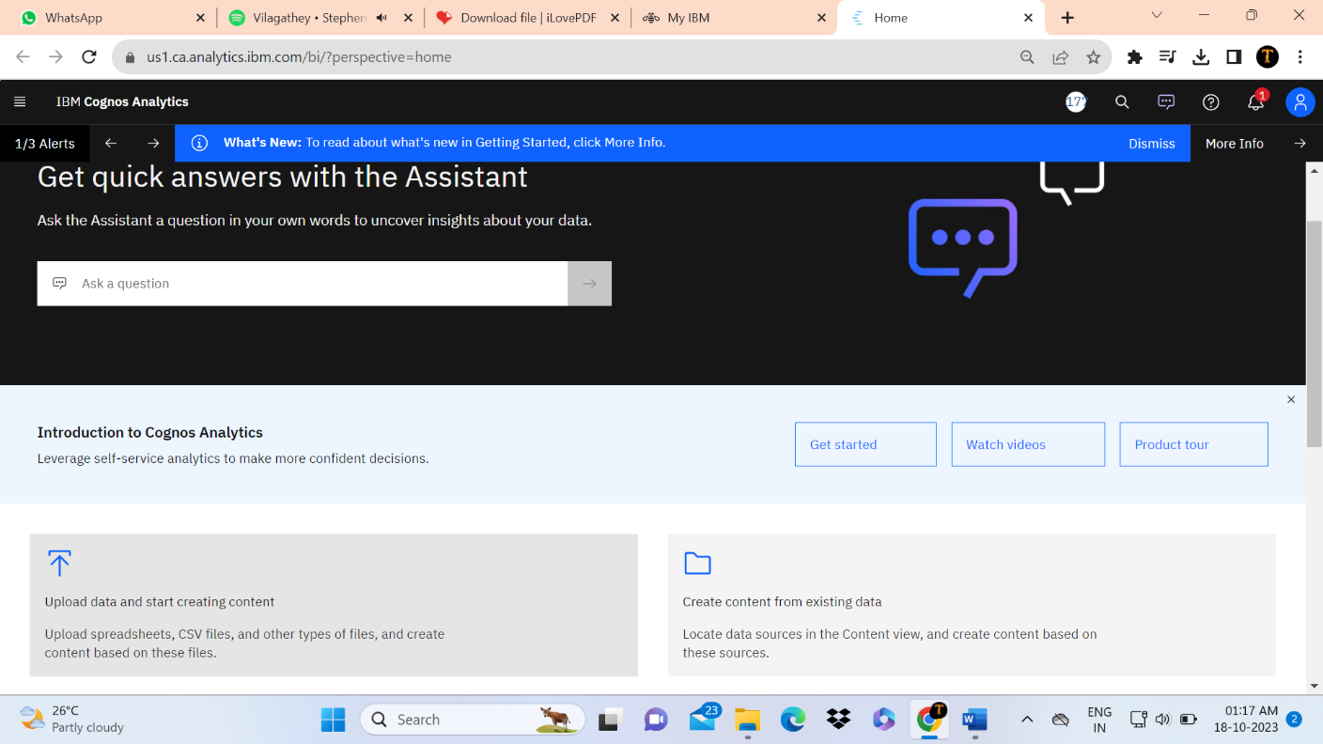

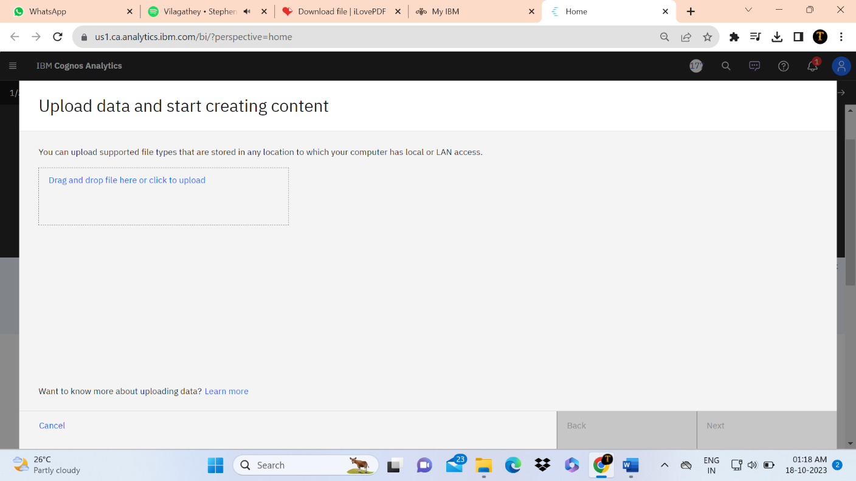

Login to the ibm cognos analytics and upload the data.

Preparing the data:

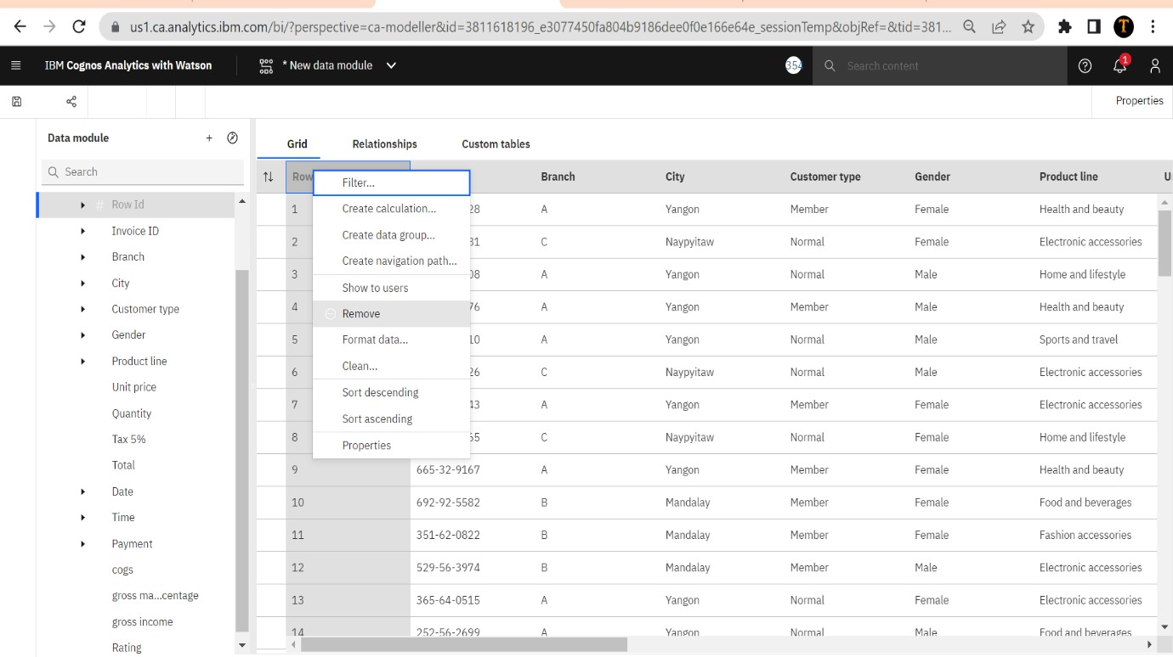

Remove the unnecessary columns ,that what we have to do on the preparation of the data.

Exploring the data:

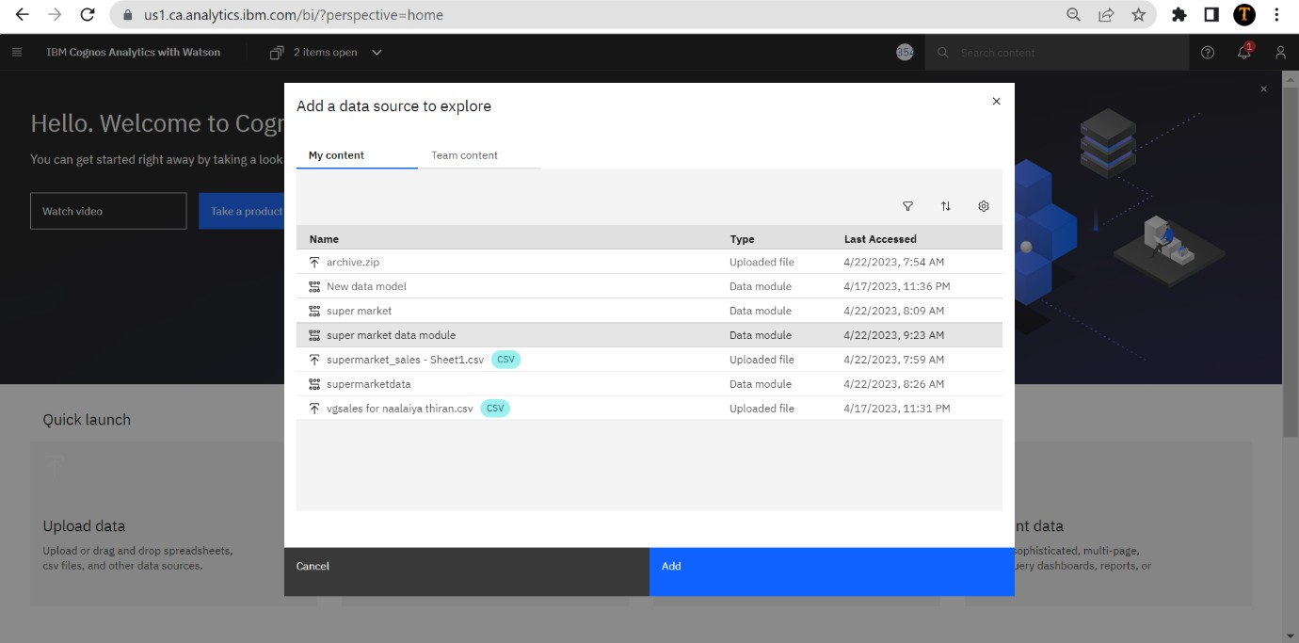

Add the data module for the exploration.

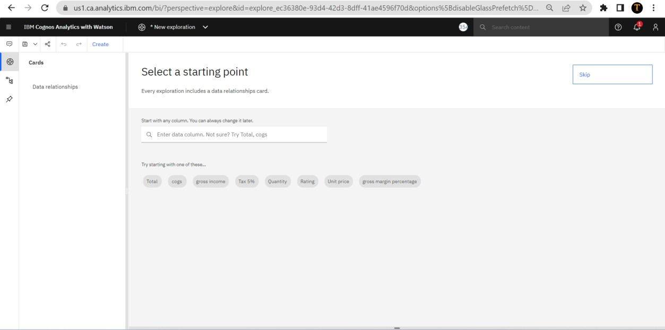

Click on create icon and choose the exploration style which we want.

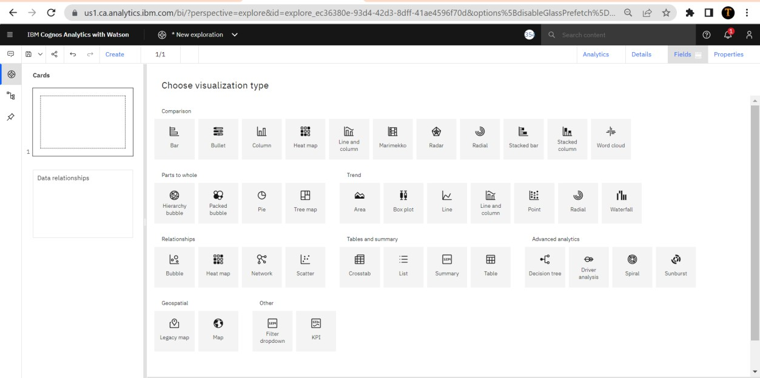

There is an lot of visualization.choose what we want.

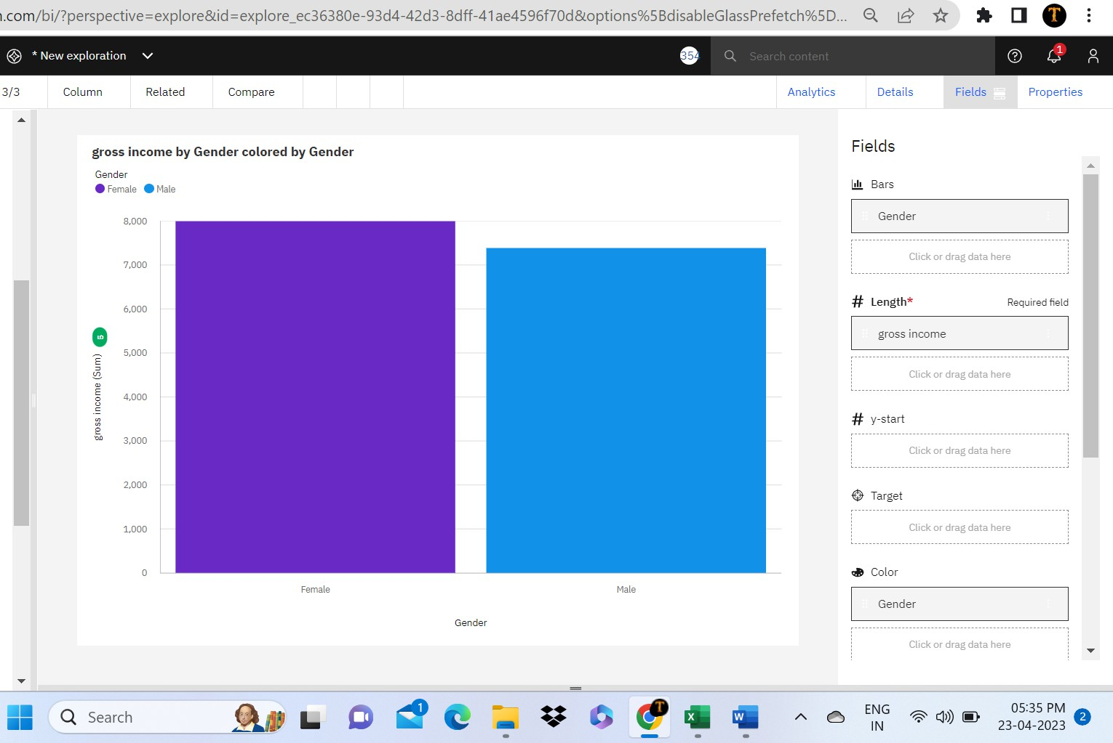

After that we have to add the necessary attributes.

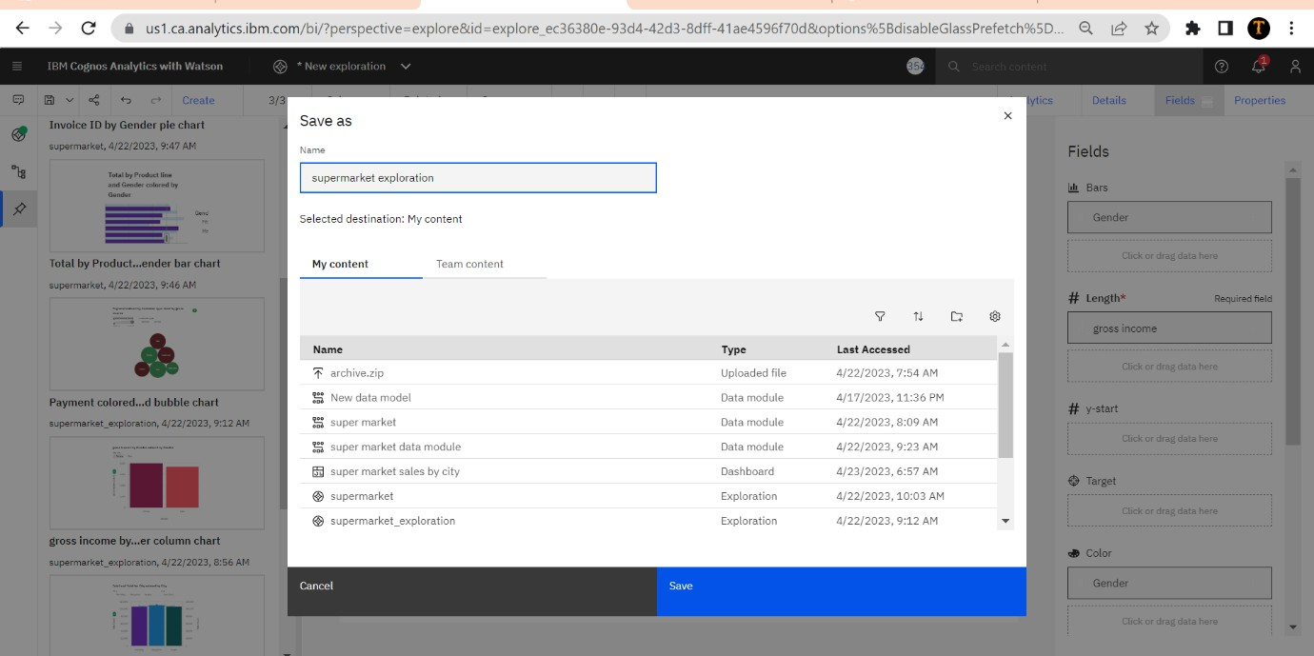

After exploring the data we need to save the data in a required name.

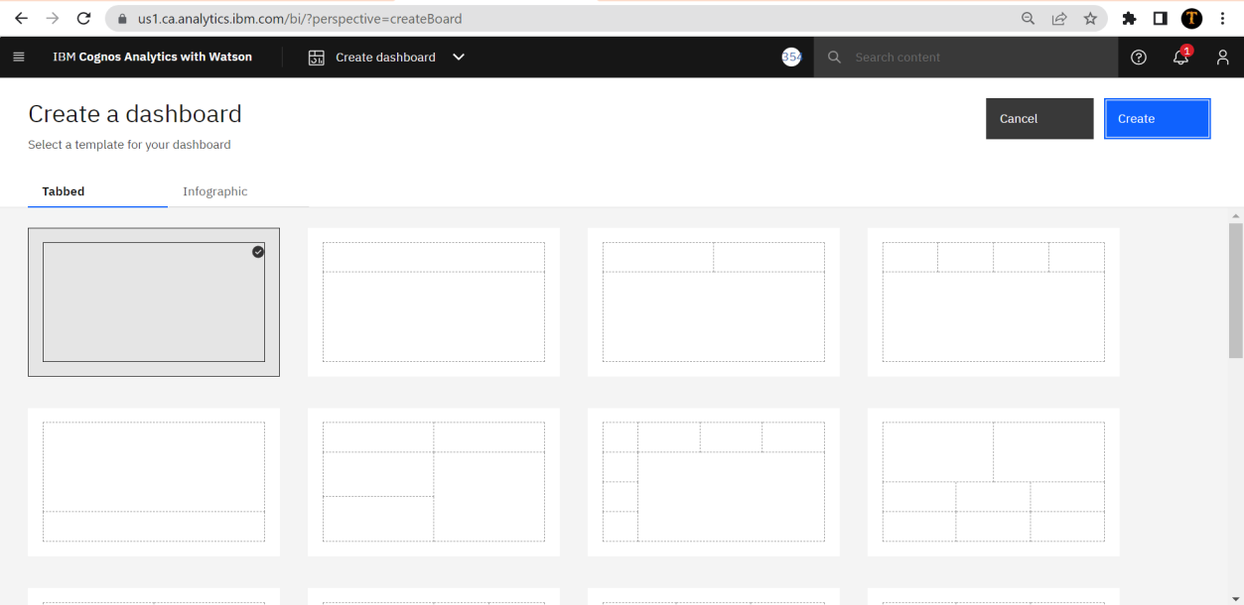Presenting the data:

Choose the dashboard what we need and create.

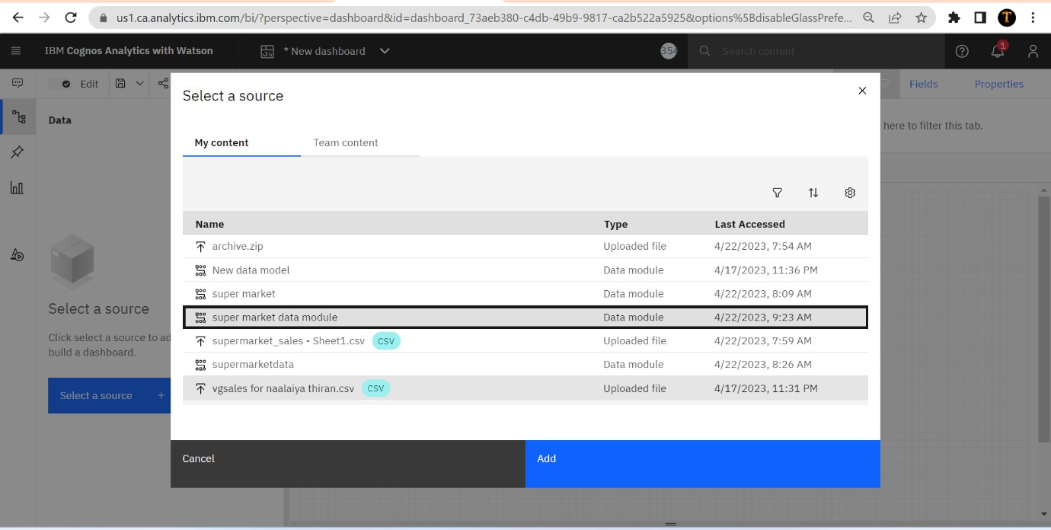

Add the file to the dashboard.

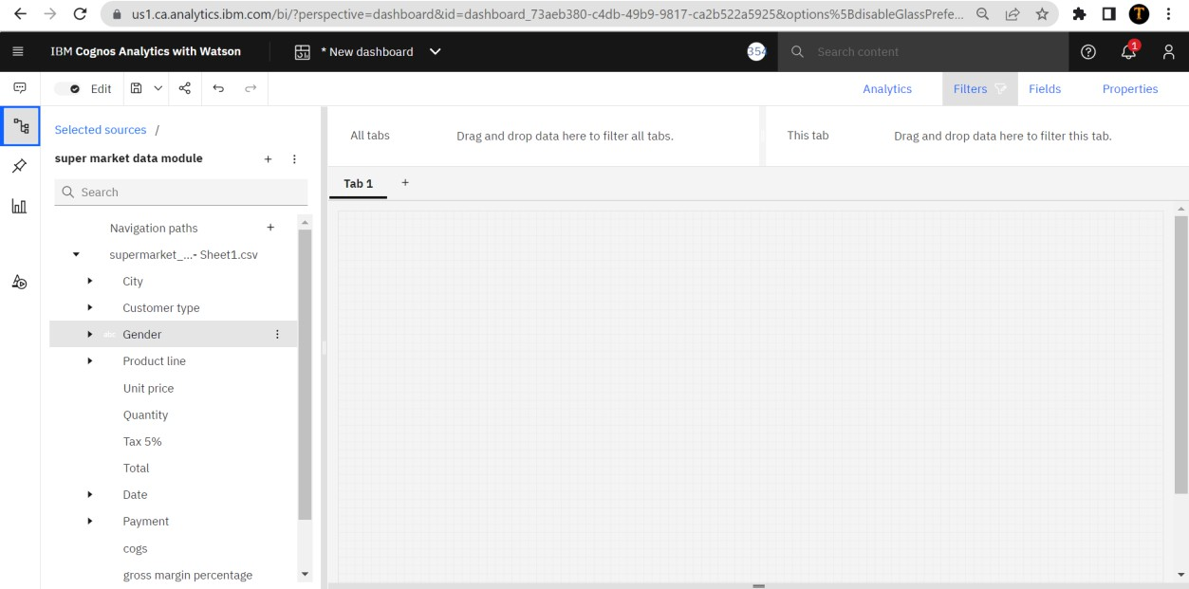

Create the tab for preparing the data.

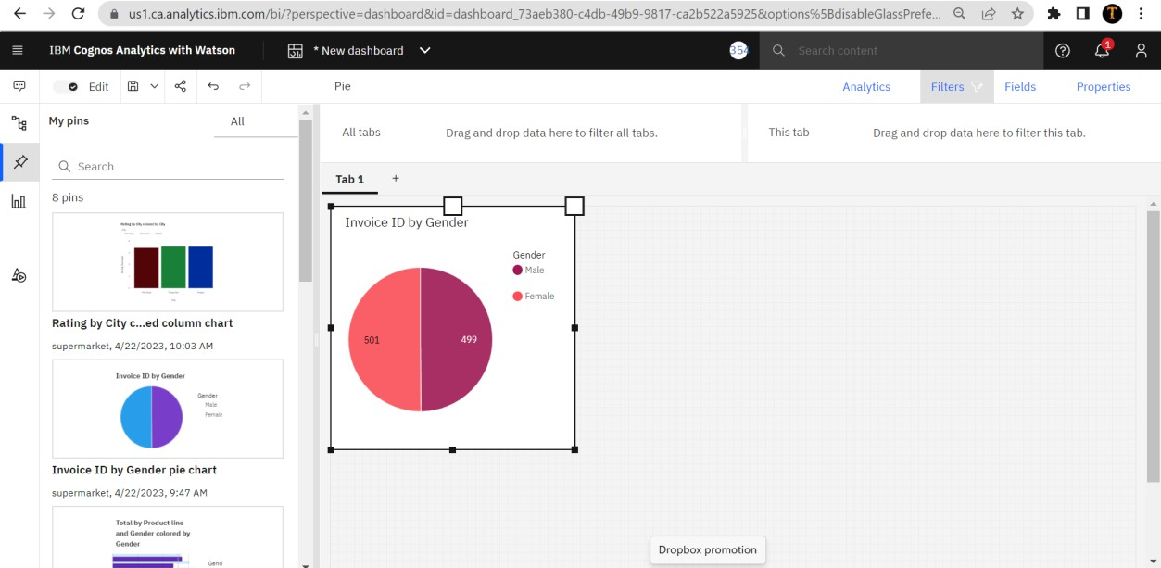

We can able to directly drag the data from the source or we can also able to plot our exploration directly from the pinned things.



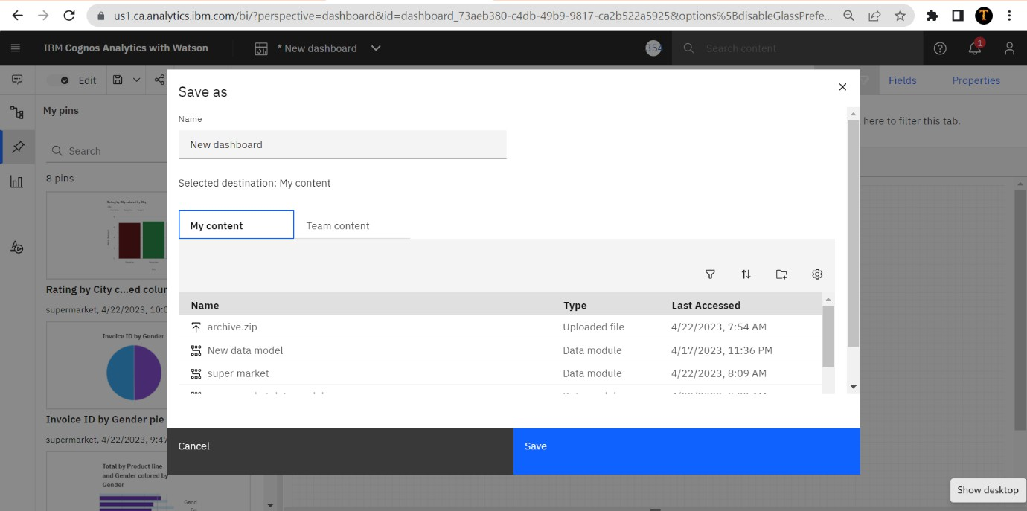

After complete visualization on tabs save all the tabs. Finally, we get the visualization of our analytics.

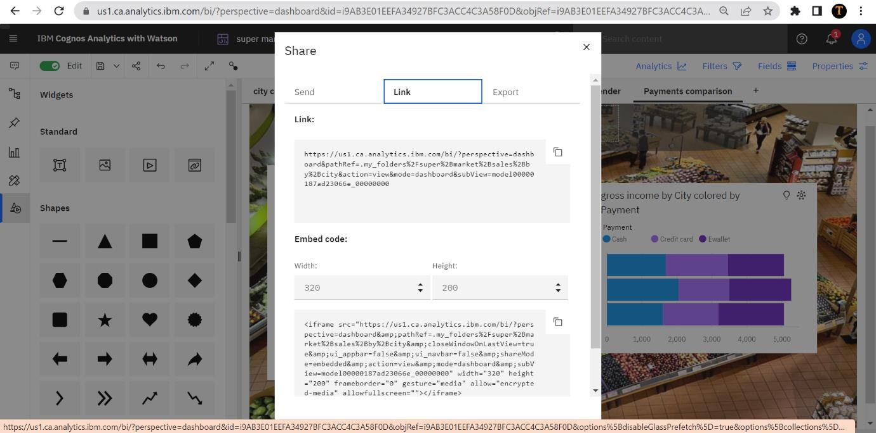

Using share option, we can able to share our presentation as direct link or the embed code.

The screenshots of the tab:

